Academic Activities information for the year 2024
- Conference/CME/Workshops/Guest lecture/Public awareness programs conducted at our college
- Our faculty conducted workshops/given talk in CME or conference/delivering guest lecture/delivering oration/part of event organized by other colleges.

Department
Community Medicine
Conducted at our college
- Public Awareness Programme: Health check-up and health awareness session was conducted in Leprosy Colony on World Leprosy Day on 30/01/2024.
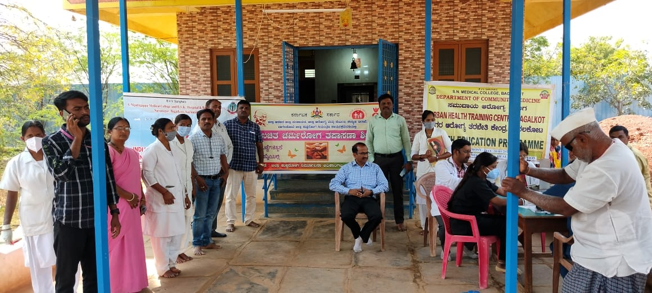

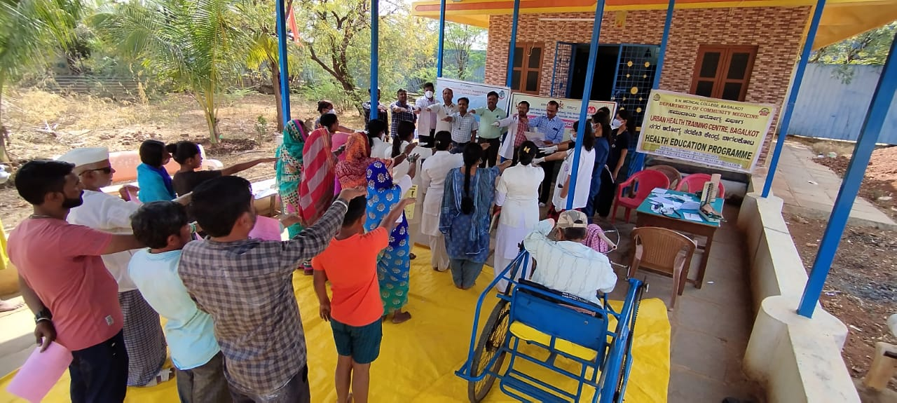

- World Tuberculosis Day – 2024 Seminar Competition under the theme “Yes! We can End TB!” was conducted from the Department in collaboration with District Tuberculosis Centre, District Hospital, Bagalkote on 22/03/2024
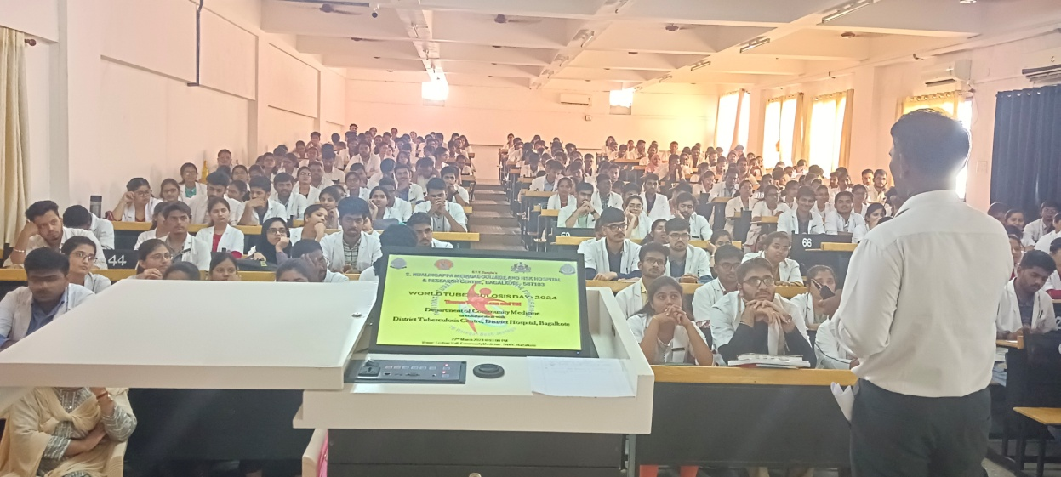

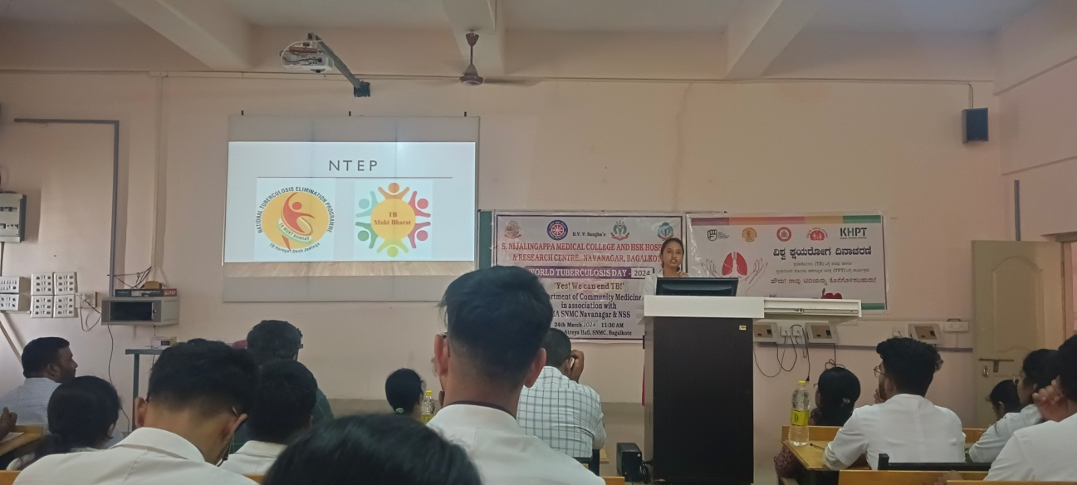

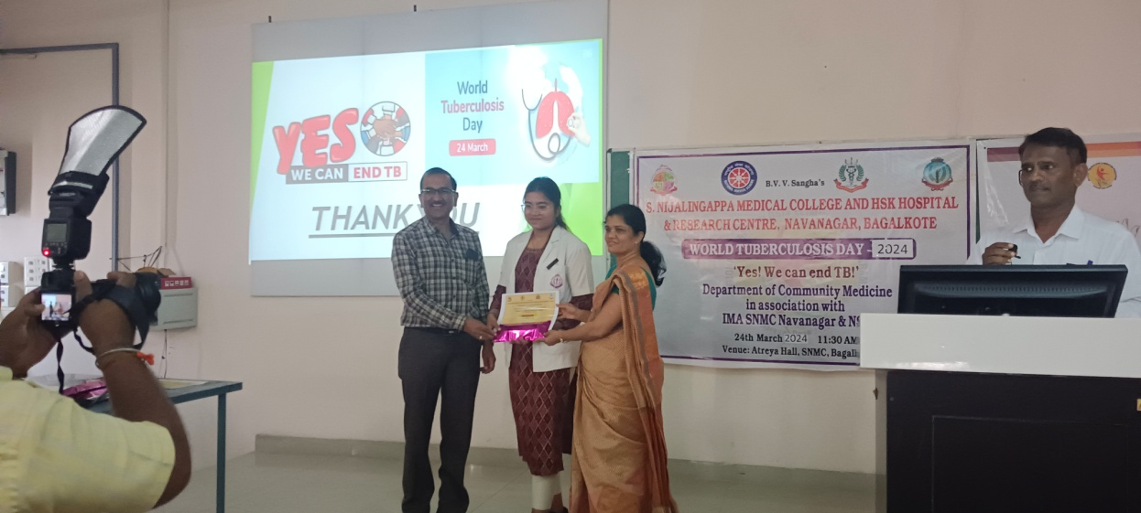

- IAPSM World health Day Quiz – 2024 under the theme “My Health, My Right” was conducted from the department with IAPSM for UG students on 08/04/2024
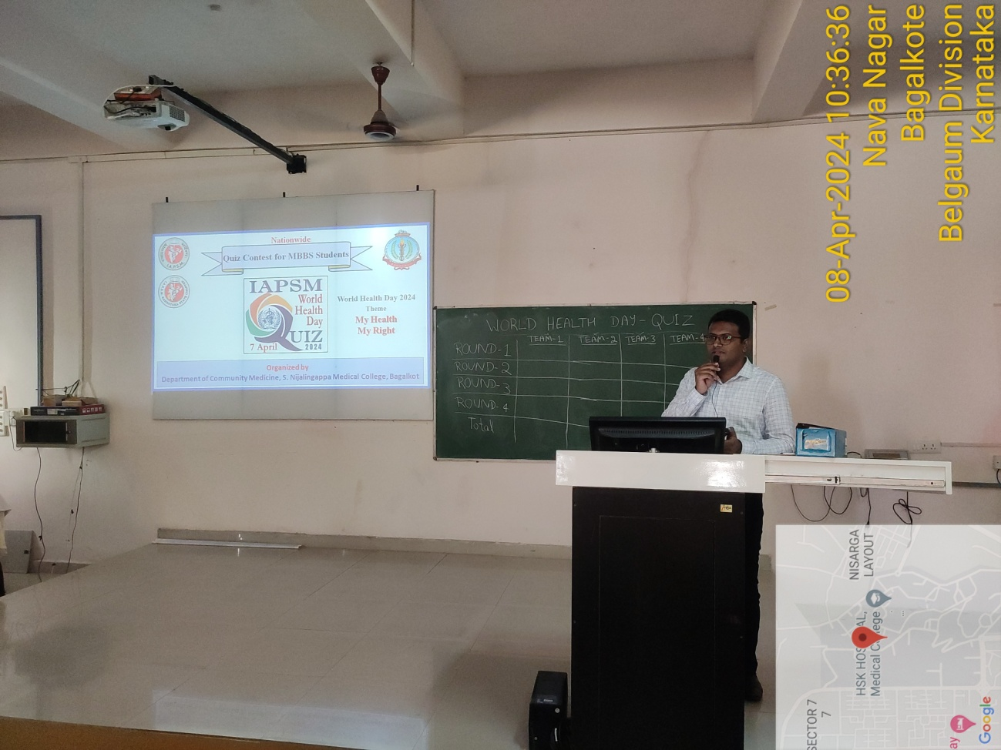

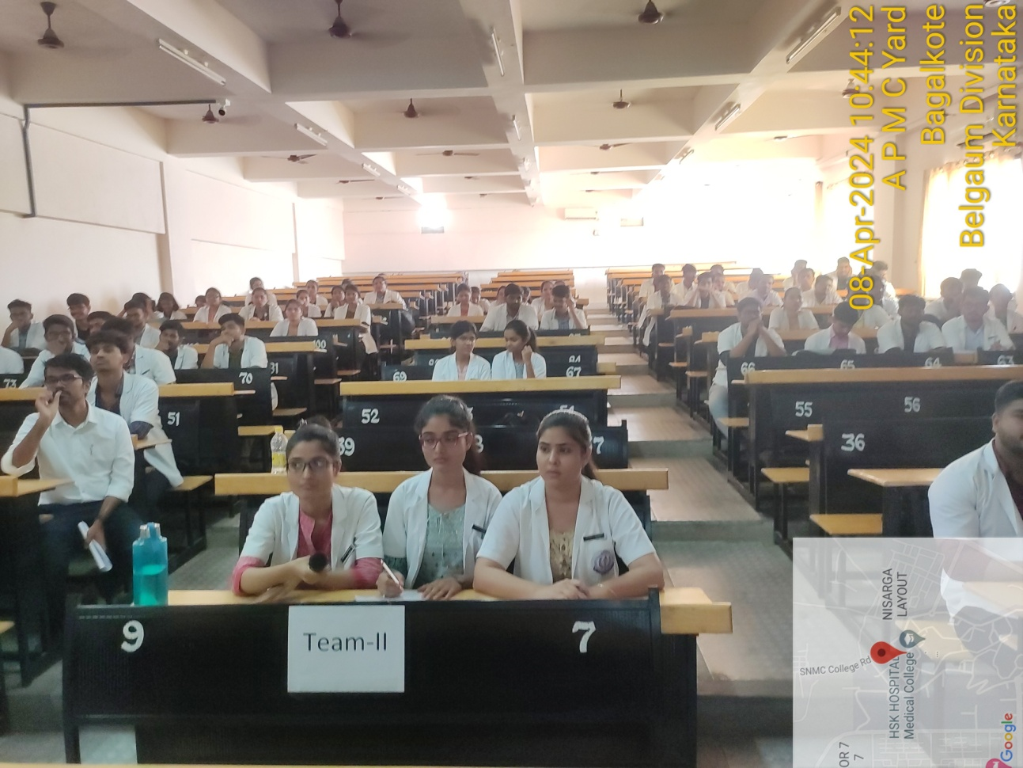

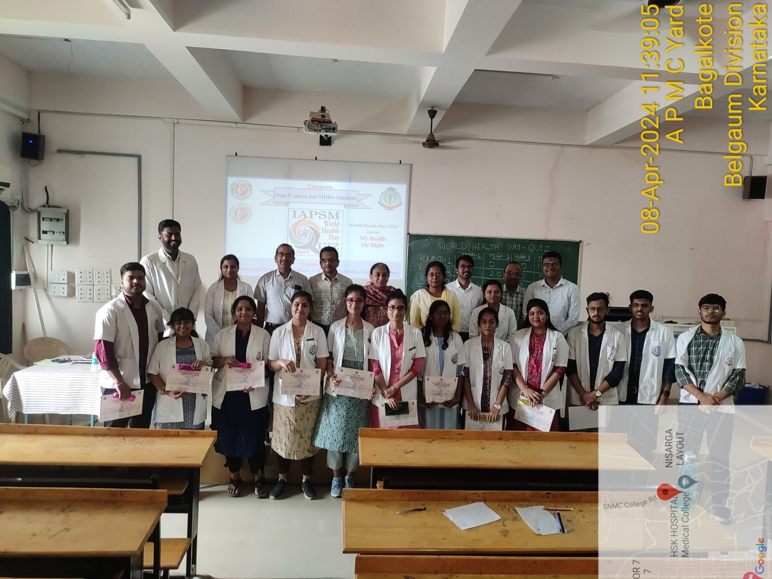

- Public Awareness Programme: UHTC, Bagalkote: Healthy Baby Competition and pediatric health talk on occasion of World Breast feeding week – 2024 conducted on 02/08/2024.
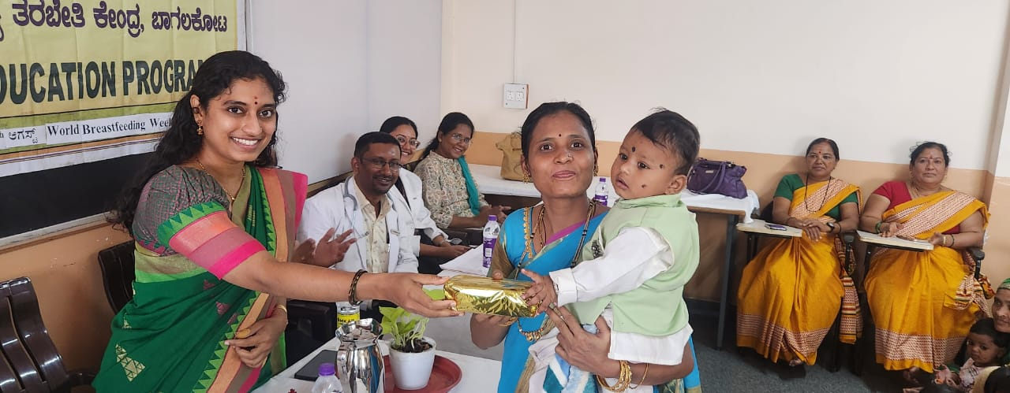

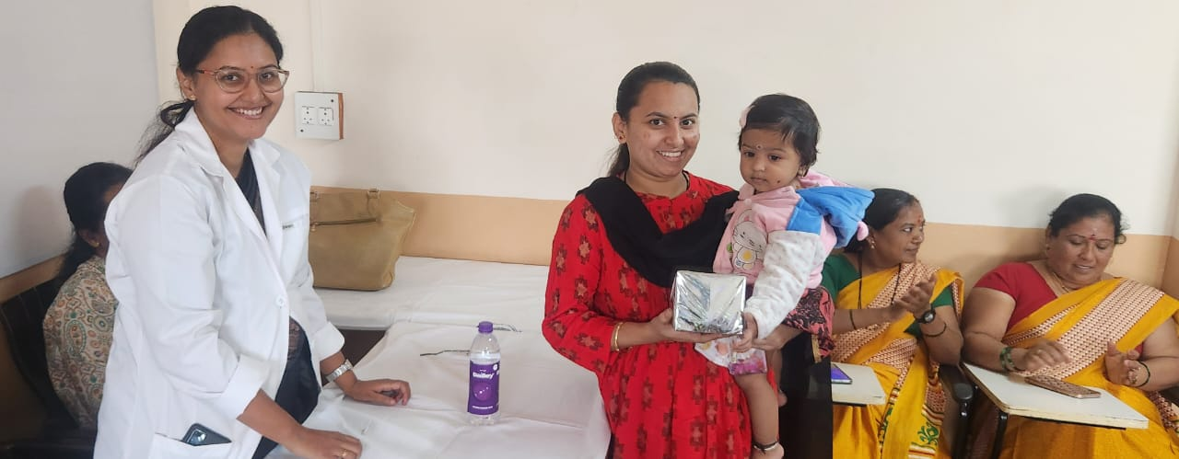

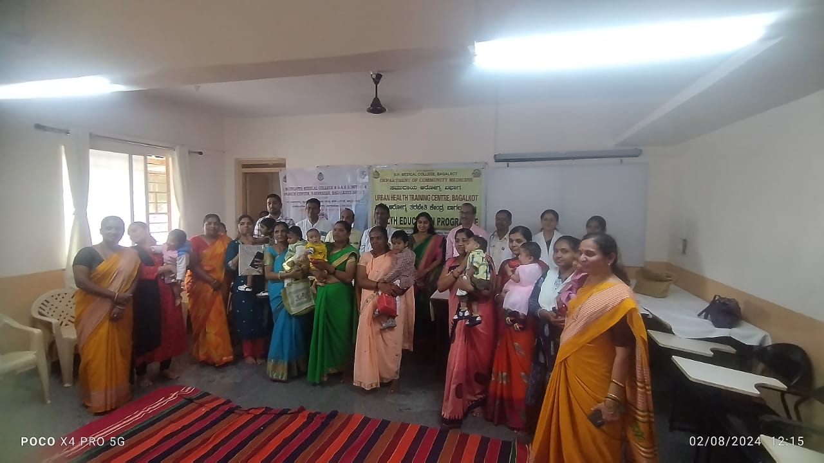

- Public awareness programme: Dr. Sachin Desai conducted geriatric health check-up camp in Old Age Home, Niralakeri, Bagalkote on 02/08/2024.
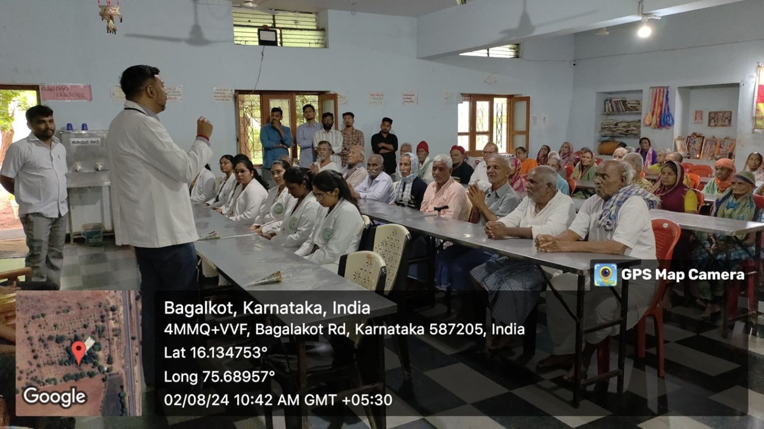

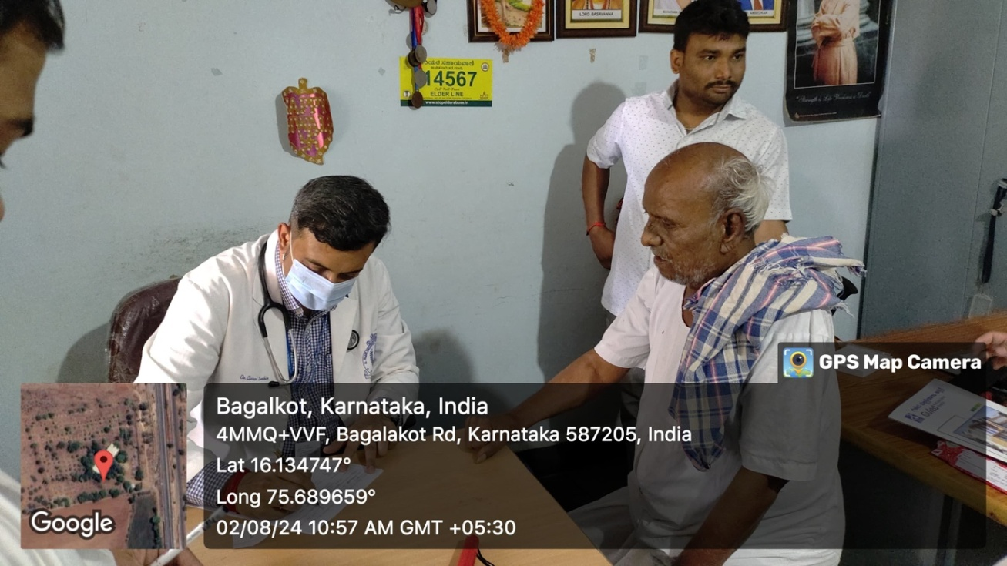

- Public Awareness Programme: RHTC, Shirur: Healthy Baby Competition and pediatric health talk on occasion of World Breast feeding week – 2024 conducted on 07/08/2024
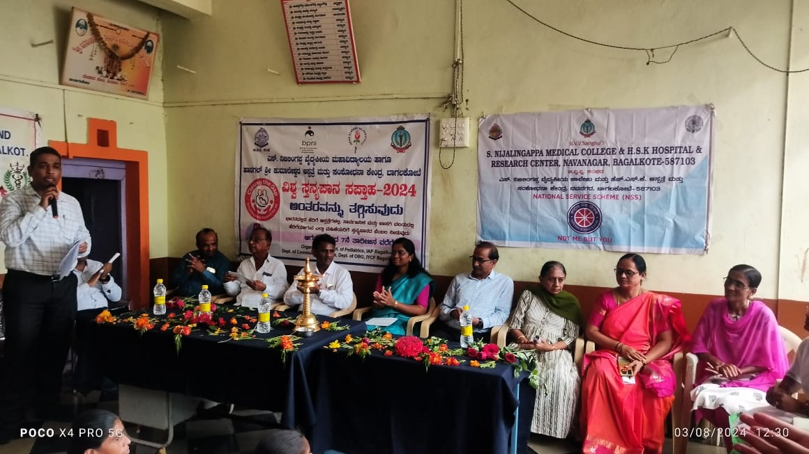

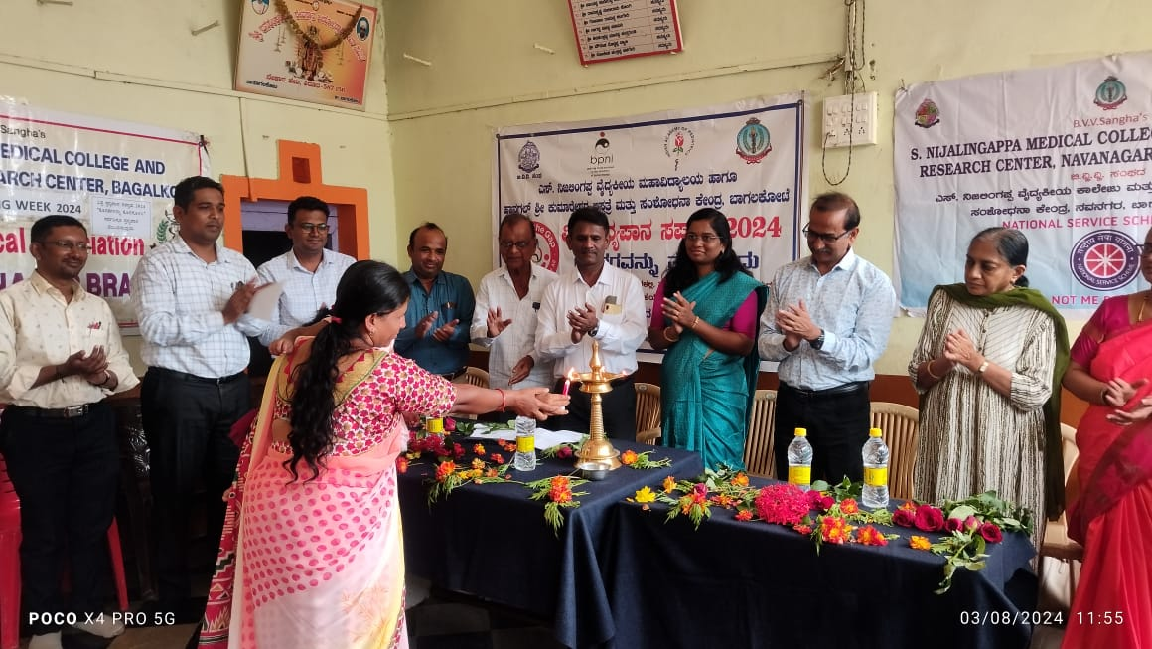

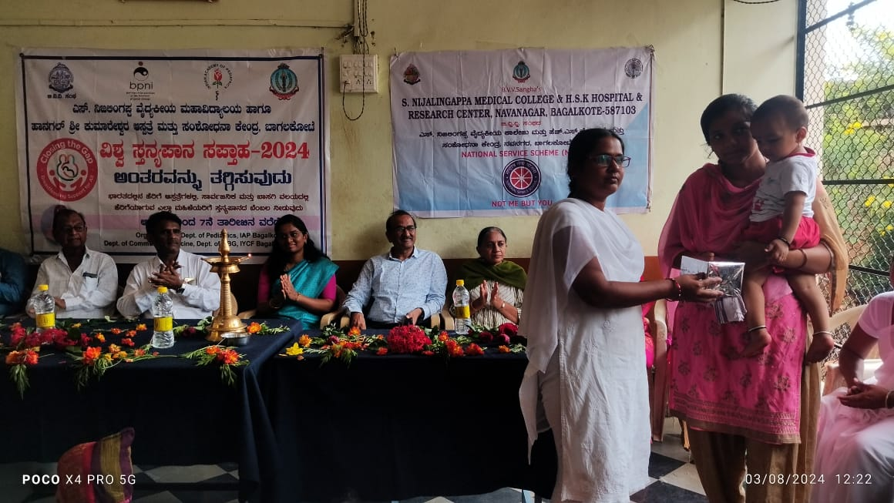

- Public Awareness Programme: Antiragging awareness week was conducted under the Department of Community Medicine on 21/08/2024 in the campus of S. Nijalingappa Medical College and HSK Hospital and Research Centre, Bagalkote.
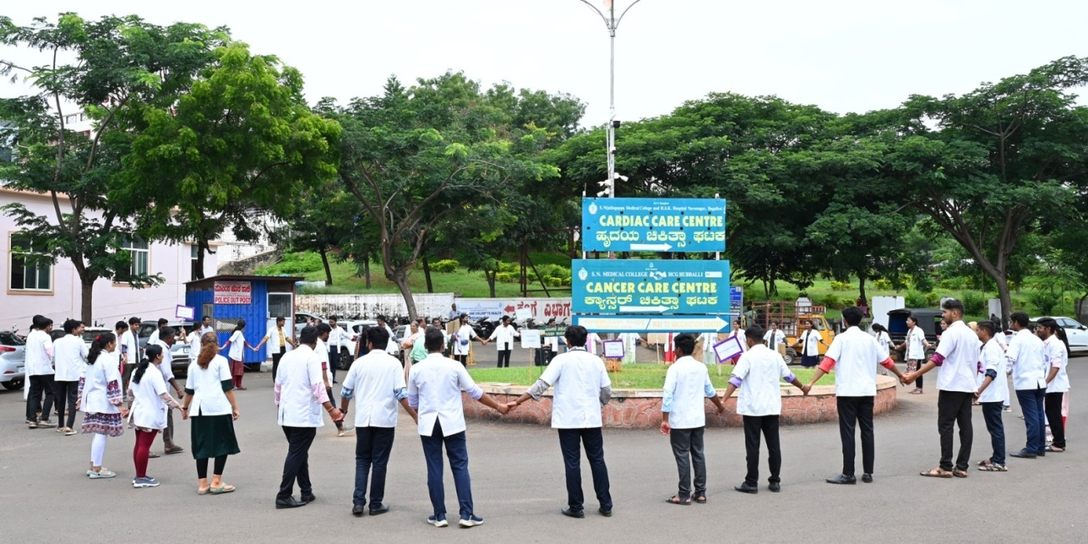

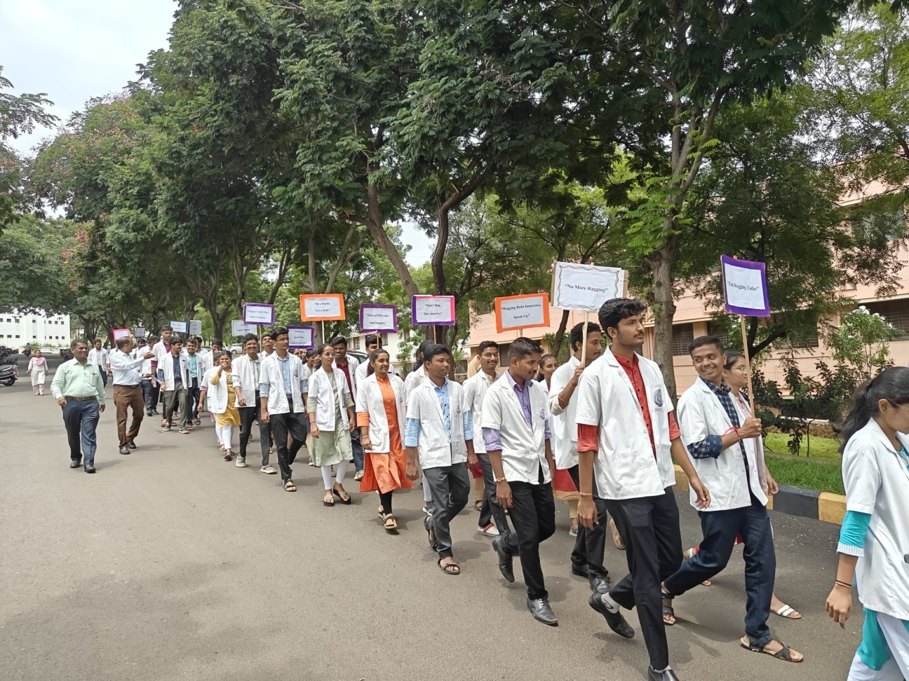

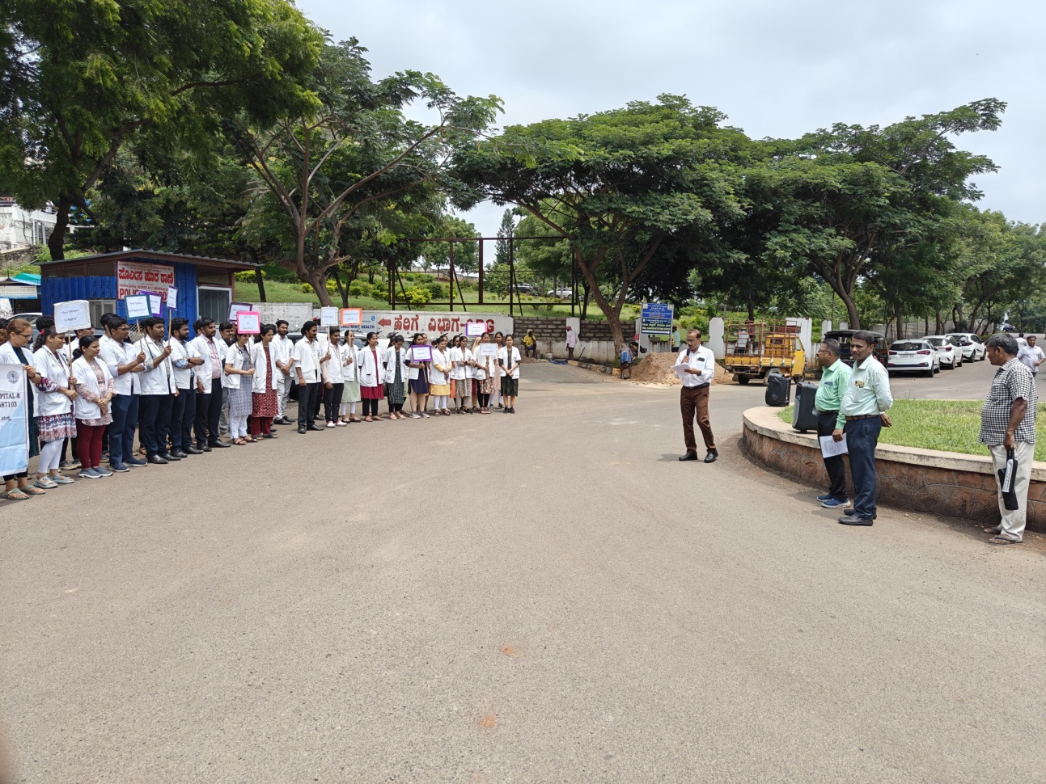

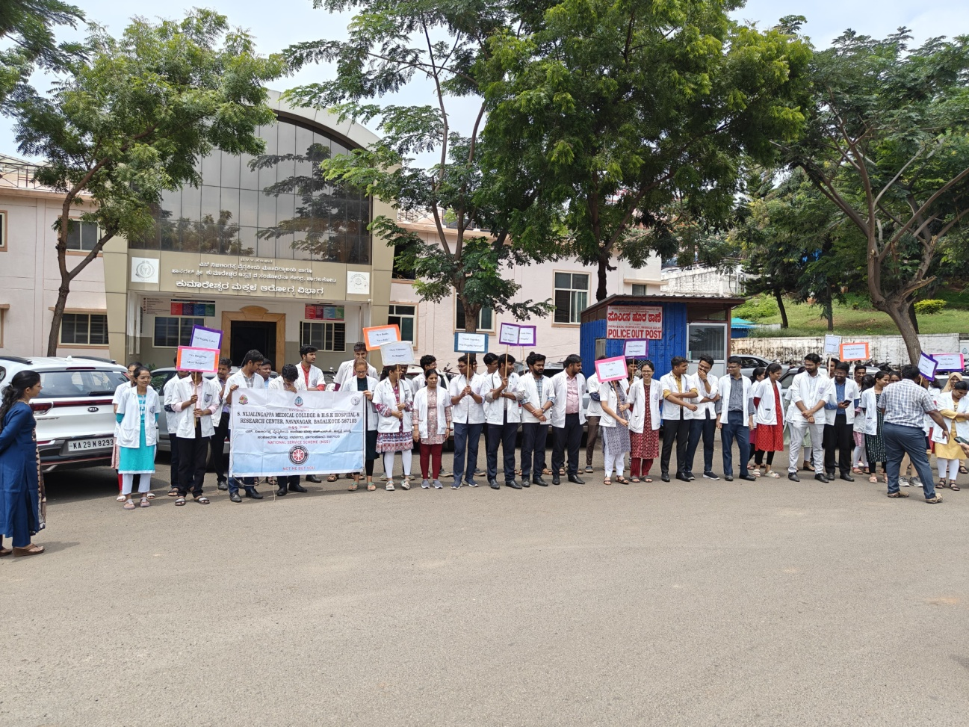

- Best Nutritious Food Competition among Anganwadi Workers was conducted in UHTC, Bagalkote under the Department and ICDS, HFW, Bagalkote on 04/09/2024.
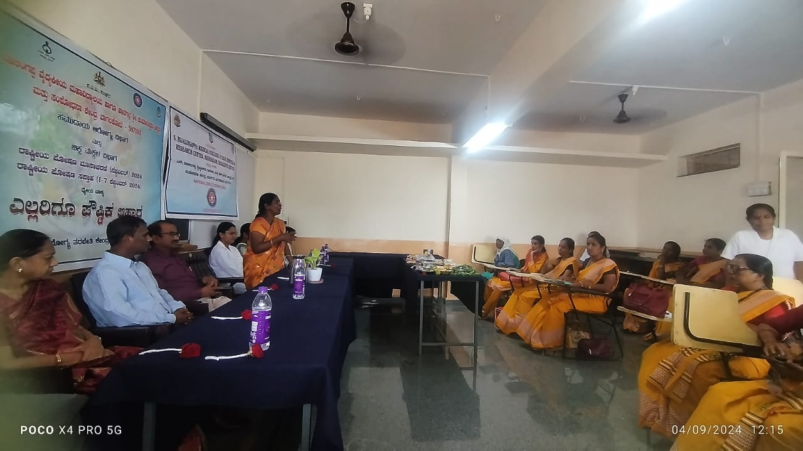

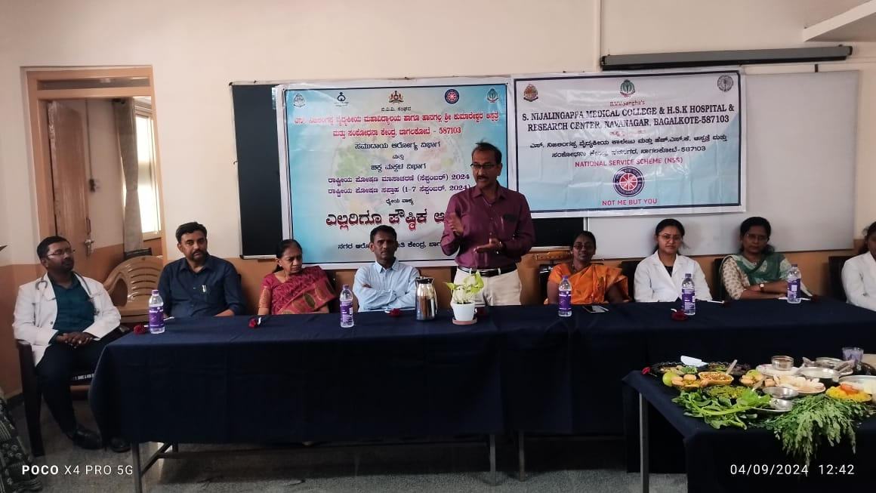

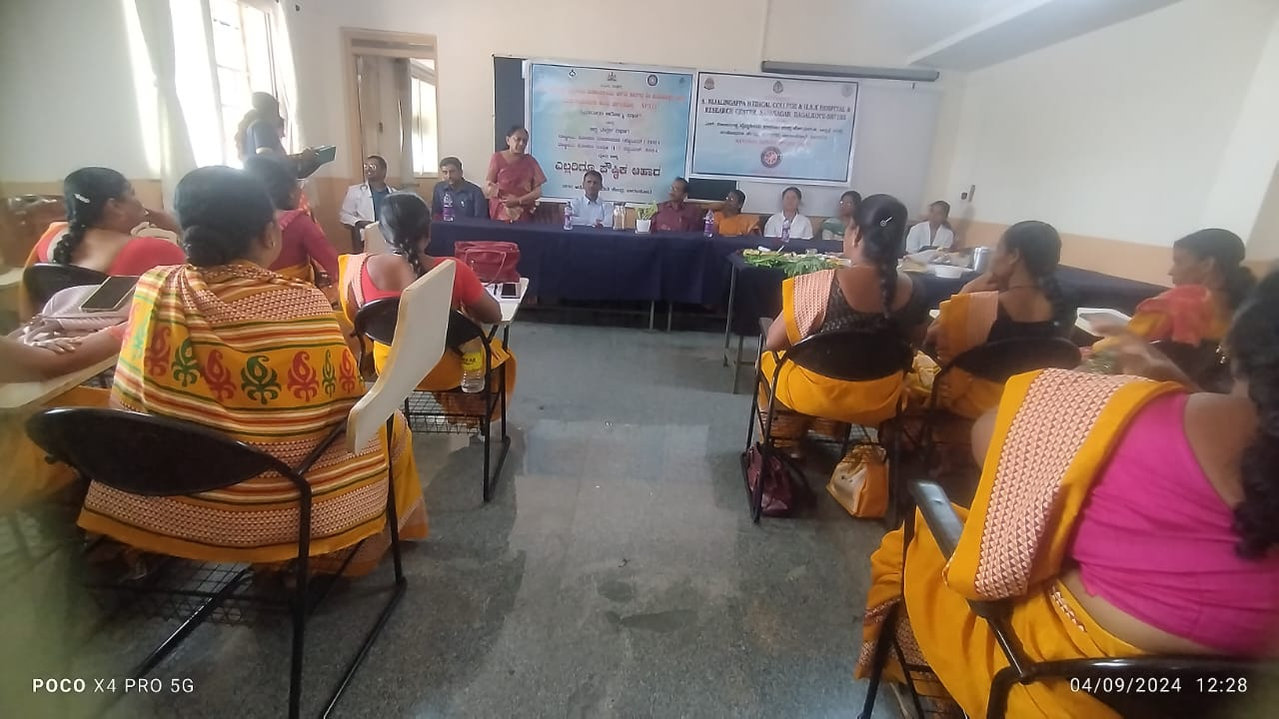

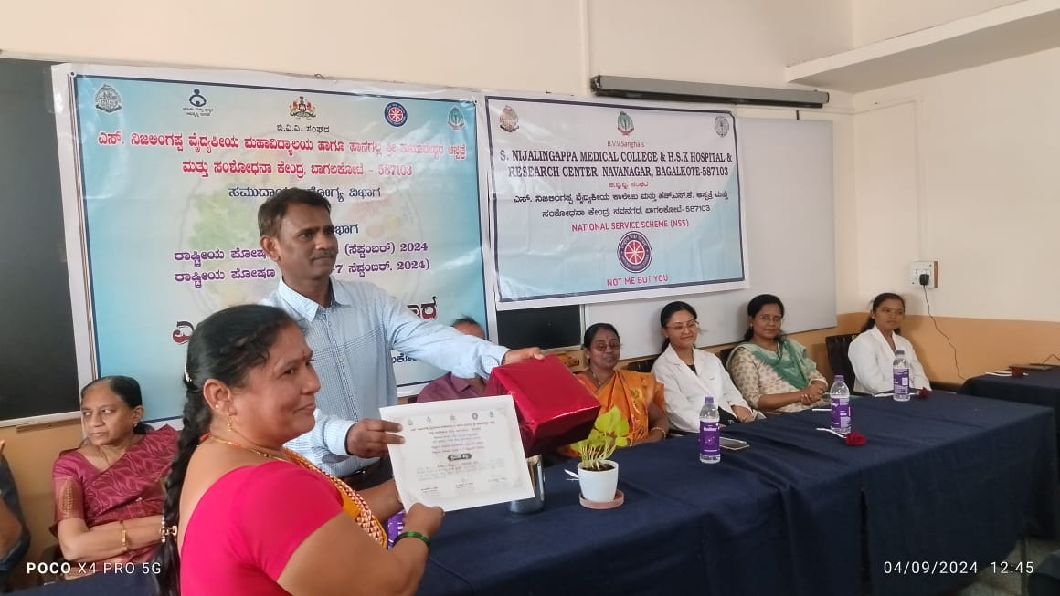

- Guest Lecture was organized under the Department, on Nutrition in the Nutrition Week – 2024. The talk was delivered by Dr. Renuka Meti, Professor, Akkamahadevi Women’s College, Vijayapura on – 27/09/2024.
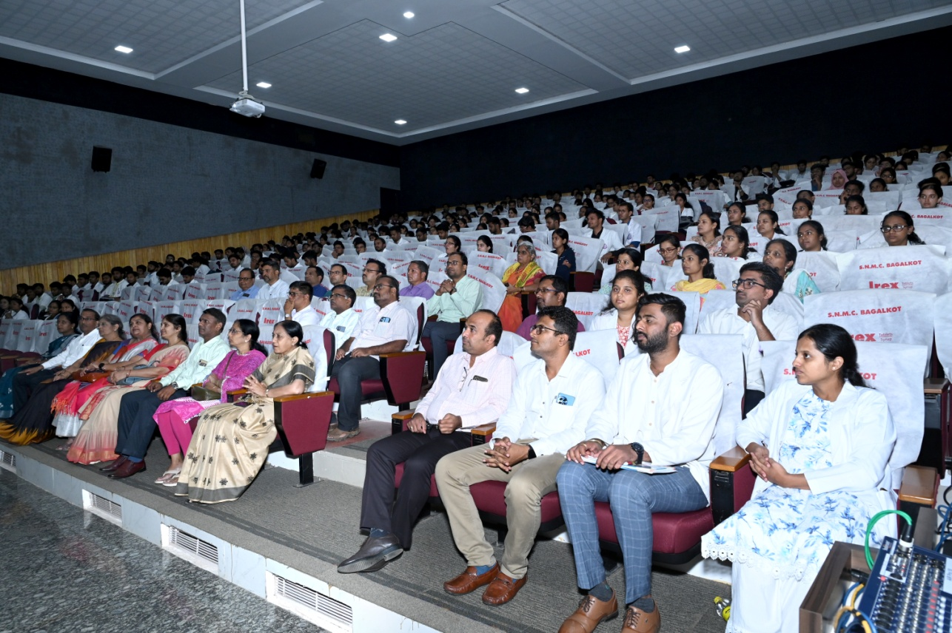

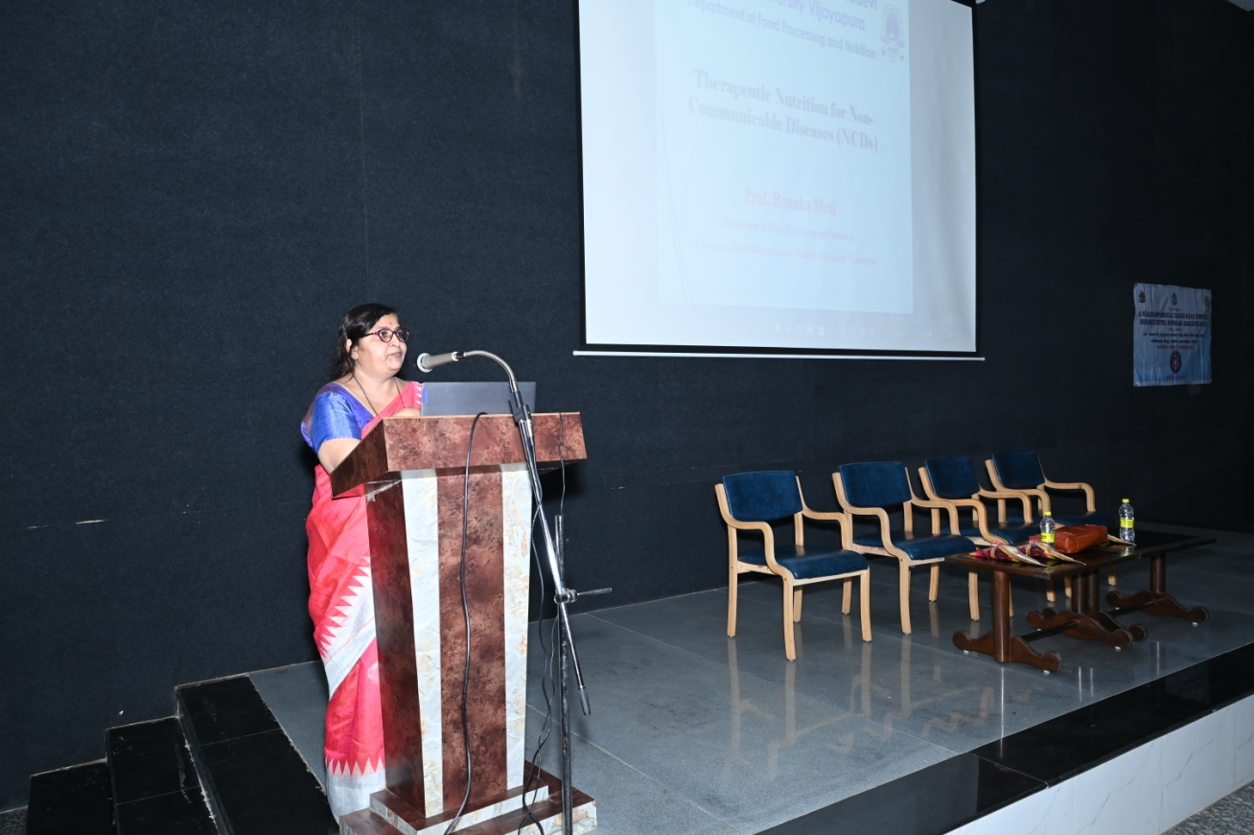

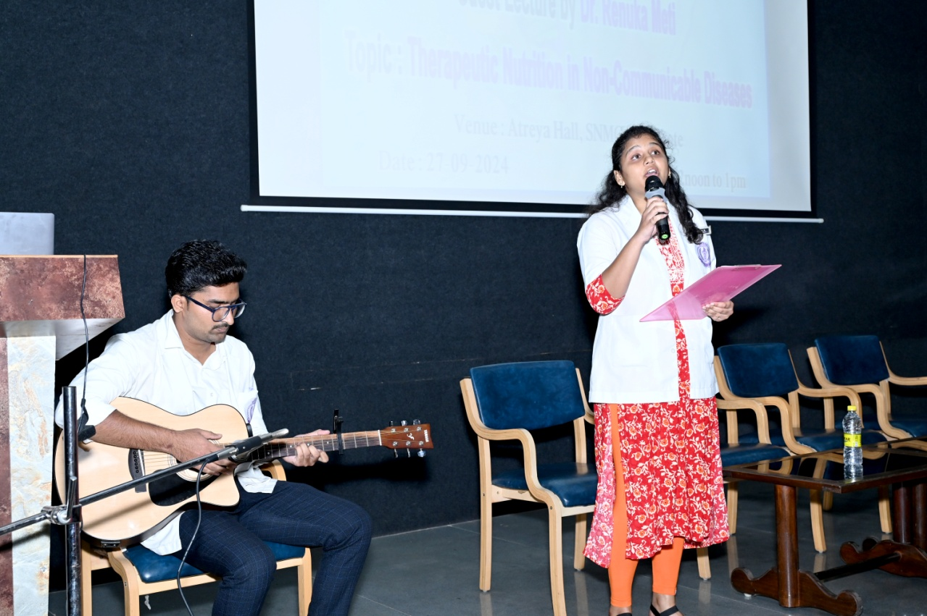

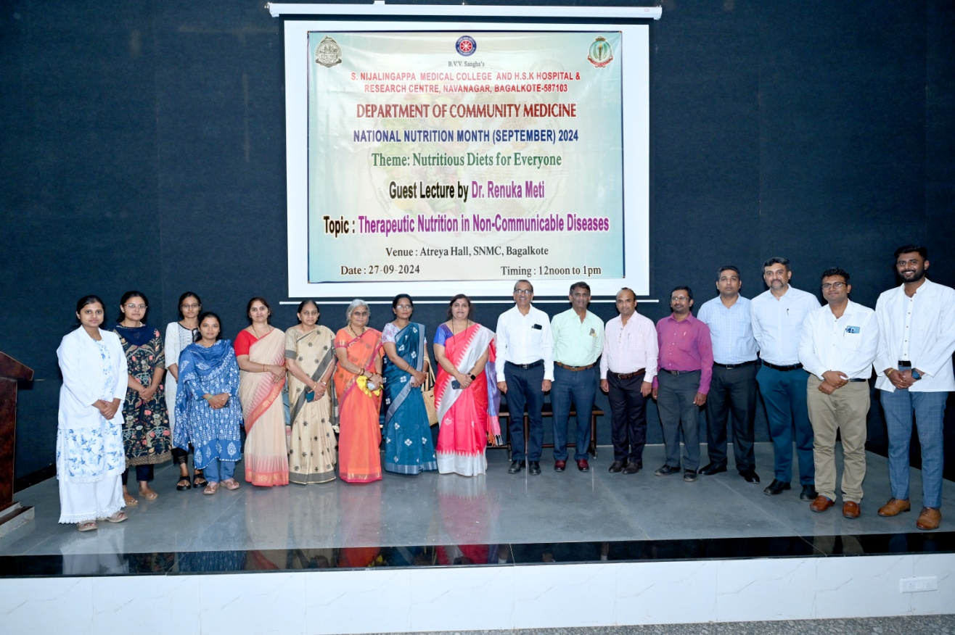

- Post Graduate Refresher Course, Refocus, Recharge, Refresh (RRR) was conducted under the Department in association with IAPSM Karnataka State Chapter on 05/12/2024 and 06/12/2024.
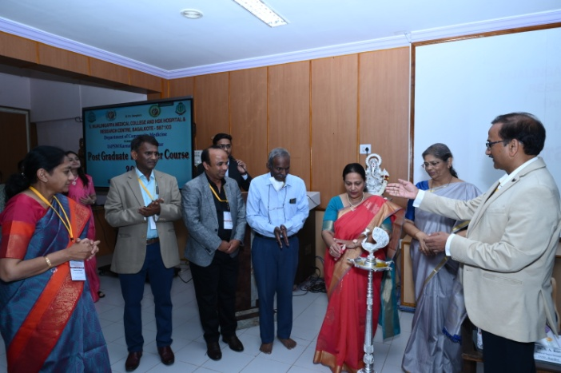

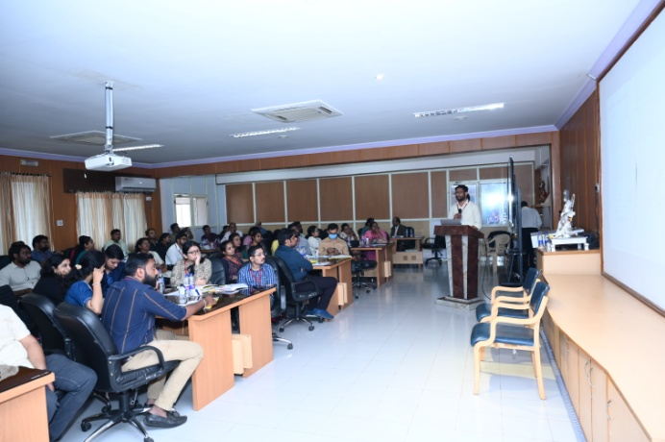

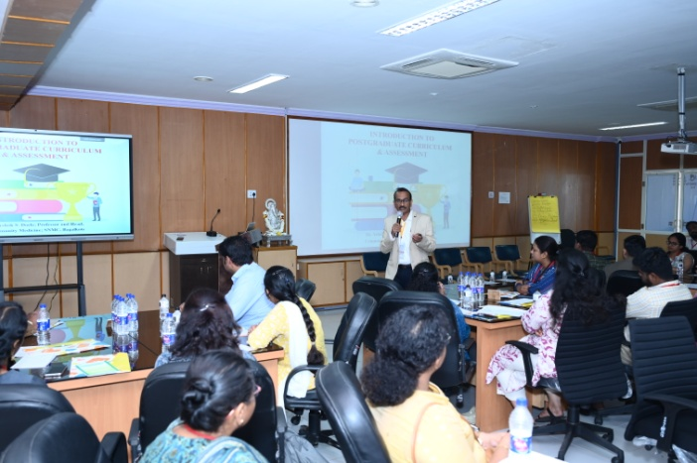

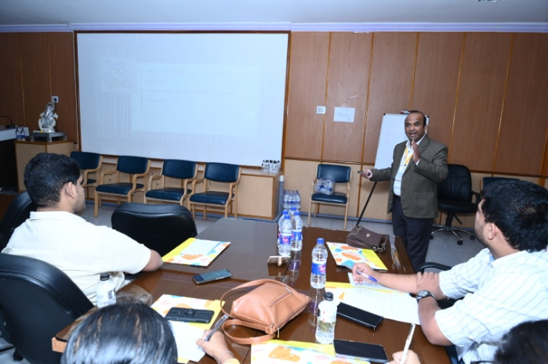

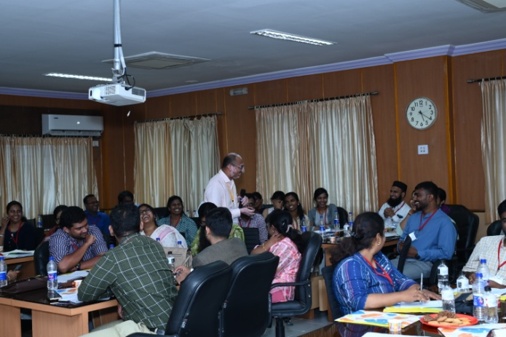

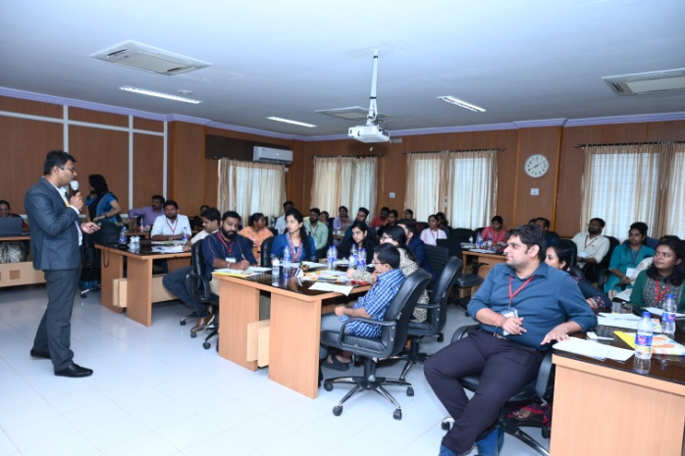

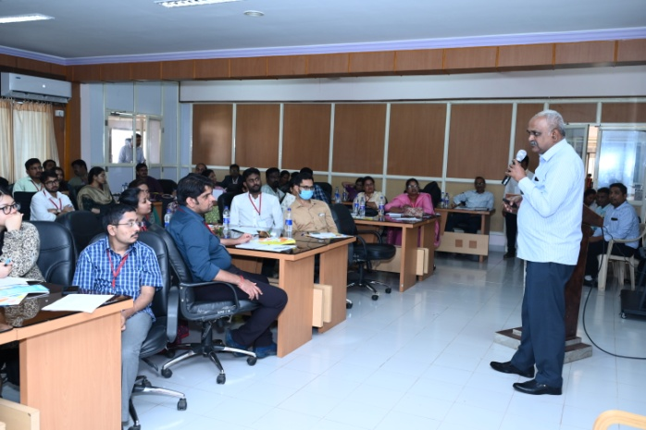

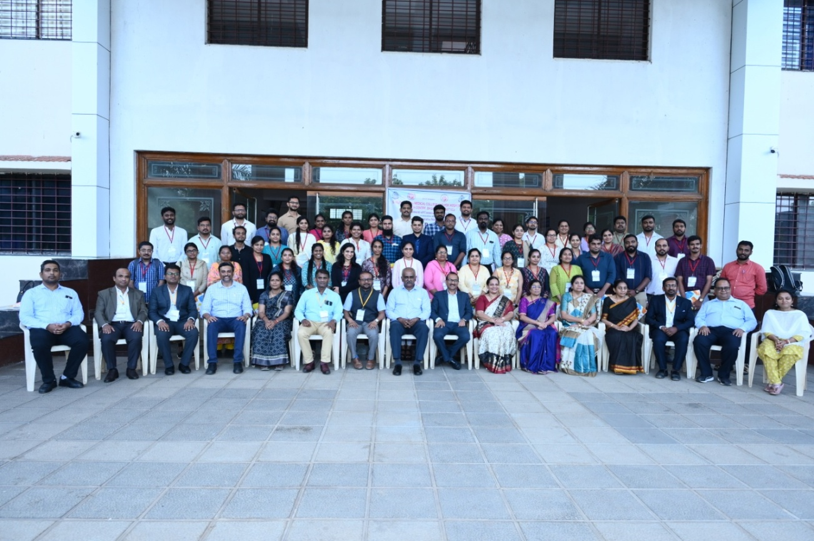

- Guest Lecture was organized under the Department, on Nipah Virus. The talk was delivered by Dr. Sanket V. Kulkarni, Joint Director, IDSP, NCDC, MoHFW, New Delhi on 27/12/2024.
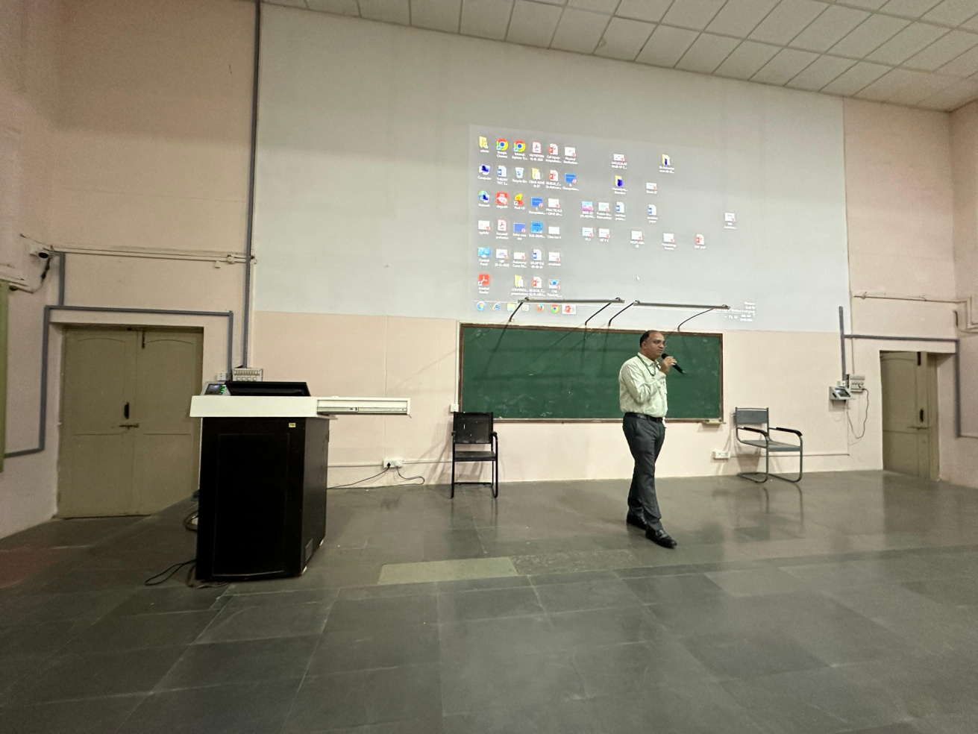

Urban Health Training Centre Activities - 2024
Sl No | Date | Activity | Place | Done by
1. | 10/01/2024 | Health Education on  Alcohol and Drug Abuse on Health and it’s Prevention on  Occasion of Birth Anniversary of Swami Vivekanda as National Youth Day 2024 | Basaveshwar School Bagalkot | Dr Santhoshkumar R. Naik  Sarojini, Nikhil  Intern
2. | 30/01/2024 | Health Check up and Health education on Leprosy and its Rehabilitation measures  along with mental health done on occasion of  World Leprosy day 2024 | Leprosy Colony, near Biomedical Waste Centre Bagalkote | Dr. Ashok Dorle  Dr Santhoshkumar R. Naik  Dr. Geeta Gangavati  Sarojini, Nikhil. Mainudinna Intern
3. | 22/4/2024 to 27/04/2024 | Immunization Survey  On the occasion of  Immunization week | Pinjar oni, Tenginamath,  Hundekar oni, Karveermath | Dr. Santhoshkumar R. Naik  Sarojini, Nikhil.  Prashant Intern
4. | 17/05/2024 | Health education on Hypertension and blood pressure check up and advice on occasion of  “World Hypertension Day” | Sabannavar oni | Dr Santhoshkumar R. Naik  Sarojini, Nikhil.  Mainudinna Intern
5. | 25/06/2024 | Health Education in  school children on  Effects of Drugs on Health & Prevention of Drug abuse and addiction | Shishuvihaar school | Dr Santhoshkumar R. Naik  Sarojini, Nikhil. Prashant Intern
6. | 10/07/2024 | Health Education  awareness about  Menstrual Hygiene | Tenginamath Government school | Dr Santhoshkumar R. Naik  Sarojini, Nikhil. Mainudinna Intern
7. | 02/08/2024 | Healthy Baby Competition  along with health talk by  Pediatric staff and our HOD Sir  on occasion of  “World Breast feeding Week”2024 | UHTC | Department Staff,  Dr Santhoshkumar R. Naik  Dr. Geeta Gangavati  Sarojini, Nikhil  Prashant Intern
8. | 01/09/2024  To  07/09/2024 | On occasion of  National Nutrition Week and Month, September -2024  Best Nutrition Food competition in Anganwadi teachers | UHTC | Department Staff,  Dr Santhoshkumar R. Naik  Dr. Geeta Gangavati  Sarojini, Nikhil. Prashant, Mainudinna Intern
9. | 21/09/2024  To 25/09/2024 | Under five health check up | Patapatigalli, Halapet,  Pendargalli, Kablegalli | Dr. Santhoshkumar R. Naik  Dr. Geeta Gangavathi  Jyoti Math,  Sunanada Tigadannavar,  Intern
10. | 10/10/2024 | Health Education on mental health and its importance  on occasion of  World Mental Health Day | Taxi Stand | Dr. Santhoshkumar R. Naik  Dr. Geeta Gangavathi  Sarojini, Nikhil  Intern
11. | 15/10/2024 | Health Education on  Importance of balanced diet and food safety  occasion of  World Food Day | Kottaleppa Temple | Dr. Santhoshkumar R. Naik  Dr. Geeta Gangavathi  Sarojini  Nikhil  Interns
12. | 22/10/2024 | Health Education on Polio and importance of immunization  On World Polio Day | Sabannavar Oni | Dr. Santhoshkumar R. Naik  Dr. Geeta Gangavathi  Sarojini  Nikhil  Interns
13. | 24/10/2024 | Health Education on Polio and importance of immunization  On World Polio Day | Water tank area  Community Congregation places | Dr. Santhoshkumar R. Naik  Dr. Geeta Gangavathi  Sarojini  Nikhil  Interns
14. | 15/11/2024 | Health Education  Diabetes Mellitus and home based management | Shirur Agasi area | Dr. Santhoshkumar R. Naik  Dr. Geeta Gangavathi  Sarojini  Nikhil  Interns
15. | 31/12/2024 | Health Education  Regular Monitoring of Blood pressure and its importance | Taxi Stand | Dr. Santhoshkumar R. Naik  Dr. Geeta Gangavathi  Sarojini  Nikhil  Interns – Shrishail, Siddaram

Rural Health Training Centre, Shirur Activities – 2024
Sl. No.: | Date | Activity | Description
1. | 16/03/2024 | Health Education | Maddi 1
2. | 24/06/2024 | Health Education and Health Check-up | Under-5 year age health check-up and awareness on nutritious food
3. | 20/07/2024 | Health Education and Health Check-up | Under-5 year age health check-up and awareness on nutritious food
4. | 01/08/2024 to 07/08/2024 | World Breast feeding Week | Health talk and healthy baby competition of under 3 year aged children
5. | 04/09/2024 | National Nutrition Week | Nutritious food competition and health talk

At other college/outside
- Annual Health Check-up was done in BVV Sangha’s English Medium High School Vidyagiri, Bagalkote by Dr. Shrinivas K. Patil, Dr. Jayaraj R. Mhetri and Dr. Santhoshkumar R. Naik along with PG – Dr. Sandhya R and interns from 06/02/2024 to 07/02/2024.
- Annual Health Check-up was done in BVVS Pre-Primary, Primary and High School (Shishuvihaar), Bagalkote by Dr. Vijayalakshmi B H and Dr. Santhoshkumar R. Naik along with PG – Dr. Sandhya R and interns on 08/02/2024 and 09/02/2024.
- Conference: Dr. Umesh R, participated as judge for faculty poster presentation at 51st IAPSM National Conference in KMC, Mangalore held from 08/02/2024 to 10/02/2024.
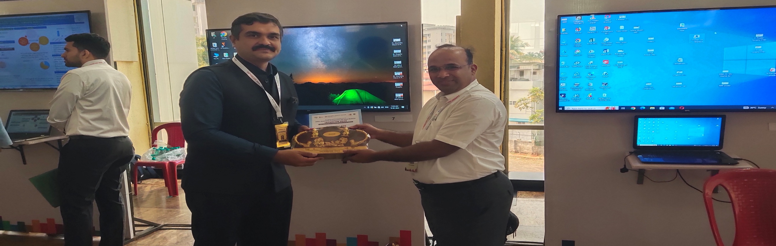

- Conference: Dr. Umesh R delivered a talk on Novel Clinical Trial Designs at State level Annual Conference on Clinical Trials Designing and Implementation hosted by KLE College of Pharmacy, Hubballi, on 23/03/2024 and 24/04/2024.
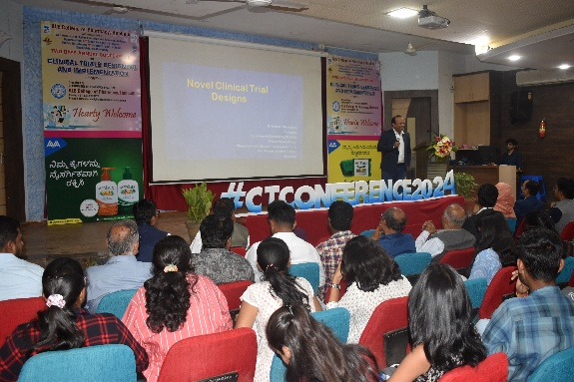

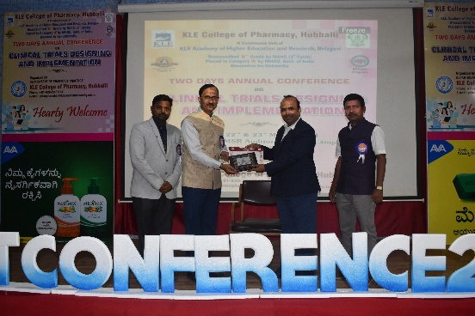

- Dr. Umesh R participated in Technical Consultation Meeting on Research Evidence for improving Maternal and Newborn Health Outcomes at India Habitat Centre, New Delhi on 01/06/2024.
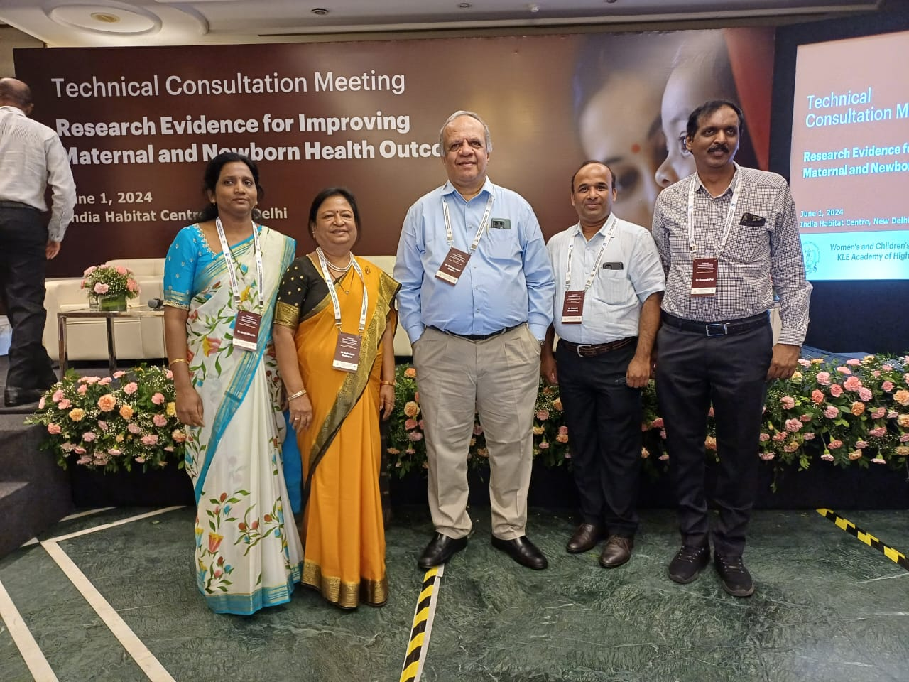

- Public Awareness Programme: Dr. Santhoshkumar R. Naik gave a invited public awareness talk on preventive care conducted by BVV Sangha’s Science College, NSS Unit, held in Haveli area, Bagalkote on 06/06/2024
- Dr. Santhoshkumar R. Naik gave guest lecture on Harmful Effects of Drugs on Health and prevention of Drug abuse and addiction on occasion of “Drug Abuse Day – 2024” in Basaveshwar New High School, (Shishuvihaar) Bagalkote on 25/06/2024.
- Guest Lecture: Dr. Vijayalakshmi B H delivered Guest lecture on importance of Promoting breastfeeding among nursing college students in Dhanush Nursing College, Bagalkote on occasion of World Breastfeeding Week held on 03/08/2024.
- Public Awareness Programme: Dr. Santhoshkumar R. Naik gave Guest Lecture on Health and Disease in Muchkhandi area, Bagalkote organized by NSS Unit, BVV Sangha’s Science College, Bagalkote on 03/08/2024.
- Dr. Basavaraj S. Mannapur gave Guest Lecture on Bio-hazard waste disposal protocols in Medicity Medical College, Ghanapur, Hyderabad on 29/08/2024.
- Worshop: Dr. Umesh R participated in the workshop onResearch Methodology and Grant Writing workshop on Maternal and Perinatal Healthorganized by JNMC Women’s and Children’s Health Research Unit, J N Medical College, KLE Academy of Higher Education and Research, Belagavi under the ambit of WHO Collaborating Centre for Research in Maternal and Perinatal Health from 02/09/2024 to 06/09/2024.

- Conference: Dr. Umesh R chaired the scientific session in 4th State Conference of IAPSM Karnataka State Chapter IAPSM-KARCON 2024 held at SS Institute of Medical Sciences and Research Centre, Davanagere on 20/09/2024 and 21/09/2024.

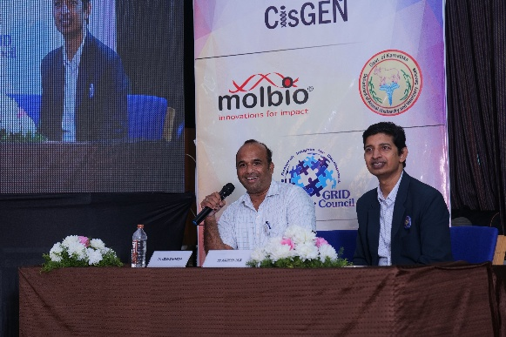

- Conference: Dr. Umesh R received the best paper award for faculty in 4th State Conference of IAPSM Karnataka State Chapter IAPSM-KARCON 2024 held at SS Institute of Medical Sciences and Research Centre, Davanagere on 20/09/2024 and 21/09/2024.
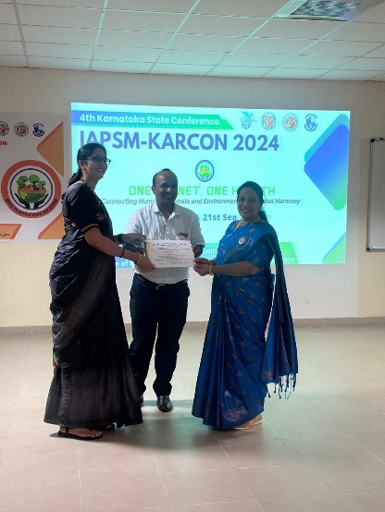

- Guest Lecture: Dr. Umesh R delivered guest lecture in 4th National Pharacovigilance Week 2024 at Hanagal Shri Kumareshwar College of Pharmacy on 23/09/2024.
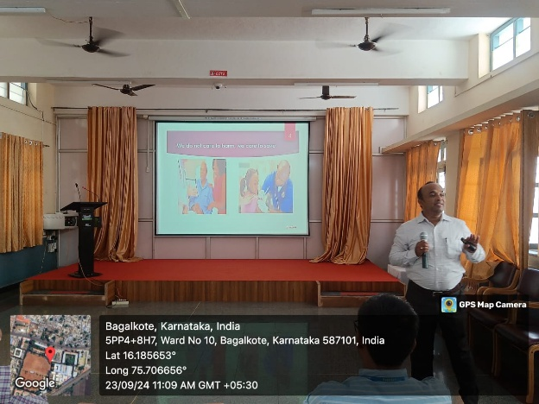

- Dr. Santhoshkumar R. Naik gave Guest Lecture on Bio-Medical Waste and E-Waste in BVVS Polytechnic College, Bagalkote on 15/10/2024.
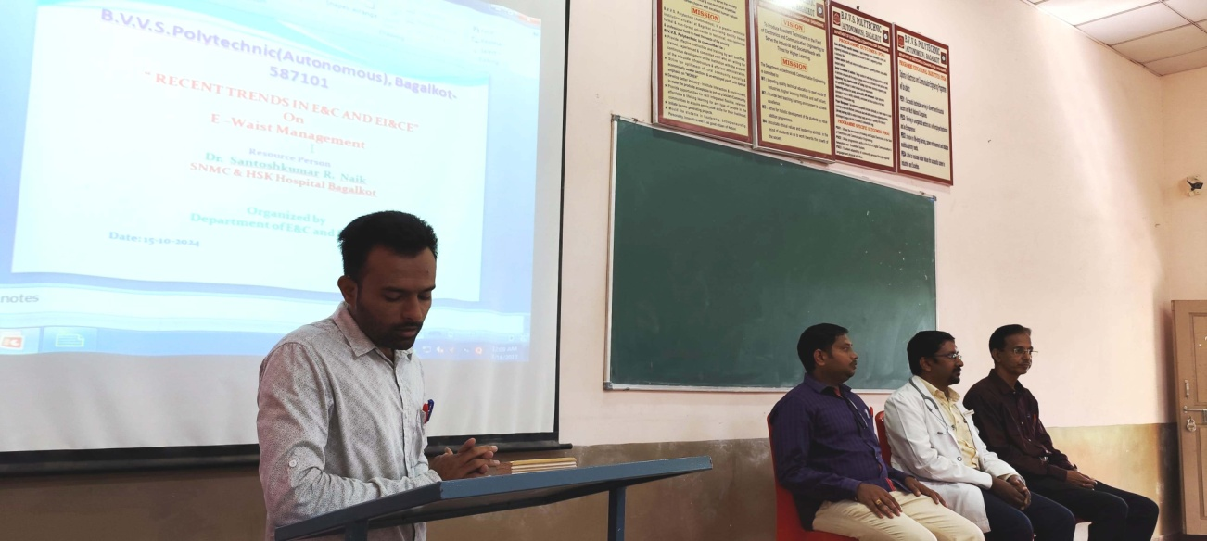

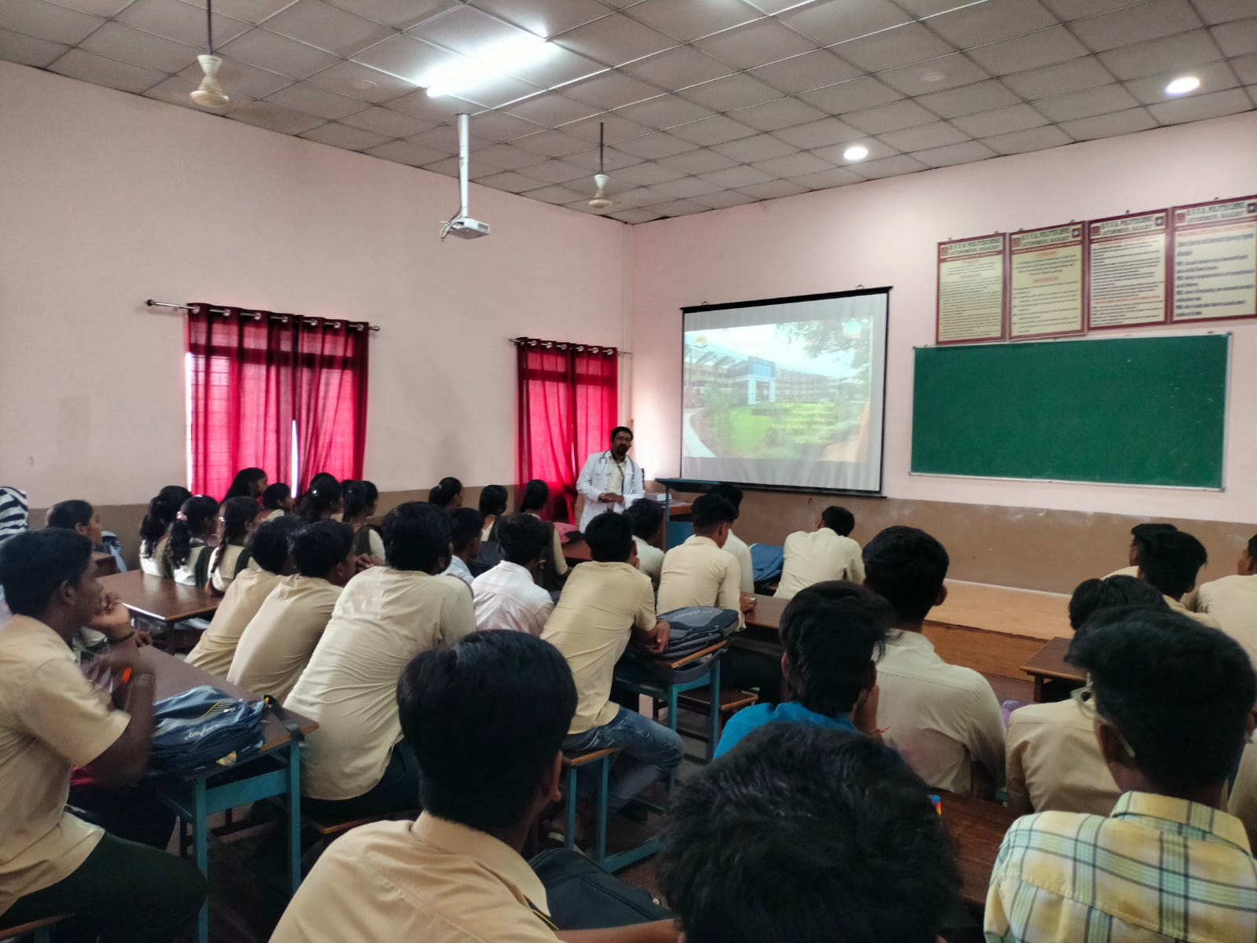

- Workshop: Dr. Umesh R presented at boot camp of master trainers of Education Methodology in Medical Sciences at RAATI centre, RGUHS, Bengaluru from 21/10/2024 to 23/10/2024.
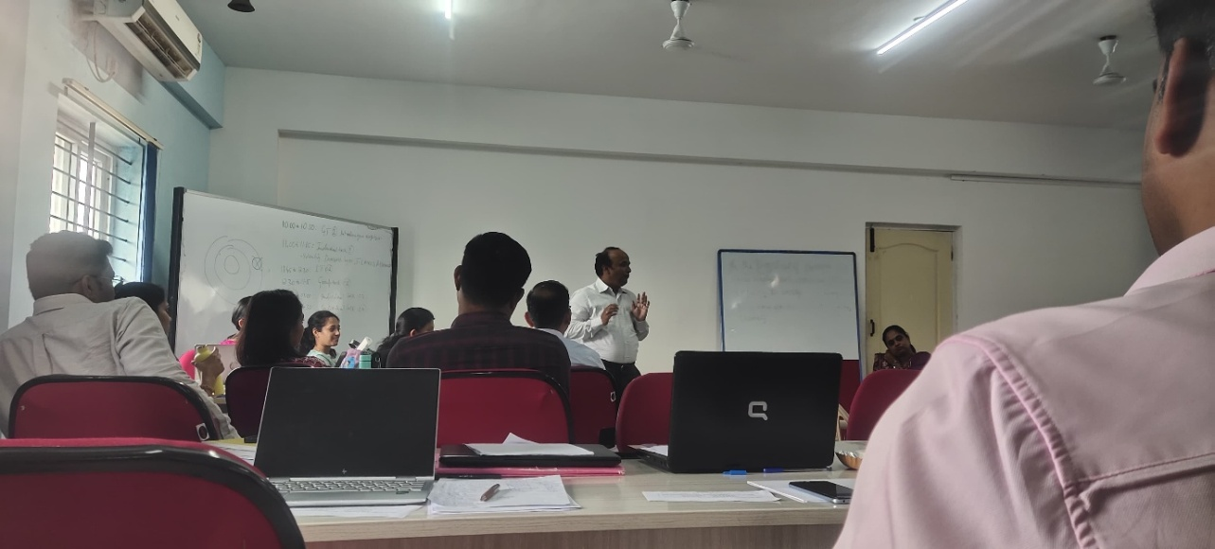

- Guest Lecture: Dr. Sachin Desai delivered Guest Lecture on Role of Music therapy for health professionals
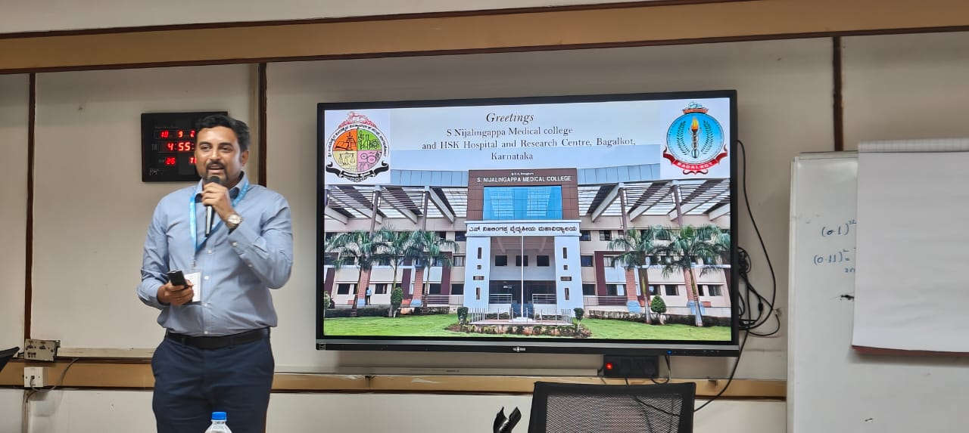

- Dr. Basavaraj S. Mannapur was Organizing Committee Co-Chairman in DIAACON – 2024 Conference held in Vijayapura on 07/12/2024 and 08/12/2024
- Dr. Basavaraj S. Mannapur judged the PG oral paper presentation in DIAACON – 2024 Conference held in Vijayapura on 07/12/2024 and 08/12/2024

- Dr. Santhoshkumar R. Naik chaired two sessions on Dento Diabetes in DIAACON – 2024 held in Vijayapura held on 07/12/2024 and 08/12/2024
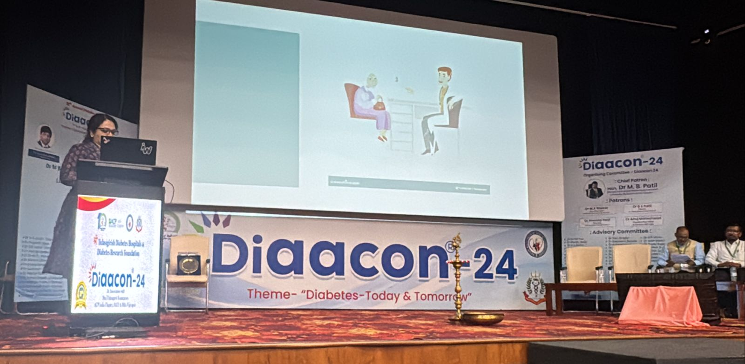

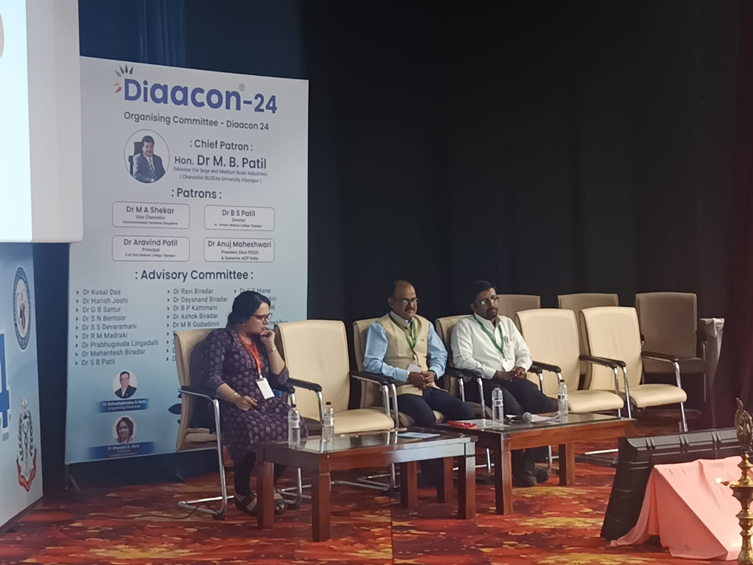

- Workshop: Dr. Umesh R gave talk in the training of mental health counselors, community health officers and head masters of Bagalkote district on tobacco and non communicable diseases and COTPA Act held in District Tobacco Control Centre, Bagalkote from 19/12/2024 to 23/12/2024.
